* **Abstract** —A robot is usually an electro-mechanical machine that is guided by computer and electronic programming. Many robots have been built for manufacturing purpose and can be found in factories around the world. Designing of the latest inverted ROBOT which can be controlling using an APP for android mobile. And in which we use Bluetooth communication to interface Arduino UNO and android. Arduino can be interfaced to the Bluetooth module though UART protocol. According to commands received from android the robot motion can be controlled. The consistent output of a robotic system along with quality and repeatability are unmatched. This robots can be reprogrammable and can be interchanged to provide multiple applications.

Now-a-days the world is optimizing and is becoming more precise by switching from the world of personal computers to laptops to android phones. Human is moving and is accepting compact technologies so that, the gap between personages and the machines is being reduced to ease the standard of living. The purpose of this project is to design and implement a compound robot. The compound robot will be able to move in four directions (left, right, forward, backward). The main intent of this project is to design and bring about a robot prototype by using Arduino Uno, Motor Driver L293D, HC05- Bluetooth module and to procure the goal of this project.

* **INTRODUCTION:**

Nowadays smart phones are becoming more powerful with reinforced processors, larger storage capacities, richer entertainment function and more communication methods. Bluetooth is mainly used for data exchange; add new features to smart phones. Bluetooth technology, created by telecom vendor Ericsson in 1994[1], shows its advantage by integrating with smart phones. It has changed how people use digital device at home or office, and has transferred traditional wired digital devices into wireless devices. A host Bluetooth device is capable of communicating with up to seven Bluetooth modules at same time through one link [2].

Considering its normal working area of within eight meters, it is especially useful in home environment. Thank for Bluetooth technology and other similar techniques, with dramatic increase in Smartphone users, smart phones have gradually turned into an all-purpose portable device and provided people for their daily use [3][4]. In recent years, an open-source platform [5].Android has been widely used in smart phones. Android has complete software package consisting of an operating system, middleware layer and core applications. Different from other existing platform like iOS (iPhone OS), it comes with software development kit (SDK), which provides essential tools and Application [6]. Using a Smartphone as the “brain” of a robot is already an active research field with several open opportunities and promising possibilities. In this paper we present a review of current robots controlled by mobile phone and discuss a closed loop control systems using audio channels of mobile devices, such as phones and tablet computers. In our work, move the robot upward, backward, left and right side by the android application such as Bluetooth Terminal.

Smart phones are becoming a basic need in day to day life with massive storage capacities, fortified processors, ample divertissement functions and vast communicating methodologies. Bluetooth is mainly used for exchanging data between different devices be it two smart phones or be it a robot and a smart phone. It mainly performs data transmission and even improve the characteristics of the smart phone, it was developed by telecom vendor Ericsson , shows its merits by incorporation with smart phones. It has changed the medium of how people uses digital devices at home or offices and has brought wireless devices in existence. The basic element of a Bluetooth is piconet, which is a collection several slave devices operating together with one master. Maximum of seven slaves can share a common master through a same link. Even several piconet can link together and form scatternet. It is useful in home environments, looking at its range or normal working area be 8 meters. Bluetooth has gradually increased users to prosecute smart phones, which have gingerly turned into a multipurpose portable device and are accessible to people for their quotidian use. Present day, android is widely accepted as an open source platform. Android consist of a complete package involving an operating system, middleware layer and core applications. A Smartphone is a cell phone built on a mobile computing platform, which has big number of boosted connectivity and computing ability than what a feature phone has.

In this project, we are overcoming the problem of traditional robots, which are usually handled with any remote controller. Reducing the remote work we are making the robot move by just a click on the cell phone with android operating system. The basic problem was a remote controller and batteries for the remote, which will be replaced by an android app. And further we are minimizing the power required to transfer any object from one place to another which can easily be transferred by the robot.

* **PROPOSED SYSTEM**

The purpose of our project is to provide simpler robot’s hardware architecture but with powerful computational platforms so that robot’s designer can focus on their research and tests instead of Bluetooth connection infrastructure. This simple architecture is also useful for educational robotics, because students can build their own robots with low cost and use them as platform for experiments in several courses. Common control architectures: The following list shows typical robot control architecture:

* ***Arduino***

Arduino is an open-source computer hardware and software company, project and user community that designs and manufactures microcontroller-based kits for building digital devices and interactive objects that can sense and control objects in the physical world. Arduino had used the Atmel atmega AVR series of chips, specifically the ATmega8, ATmega168, ATmega328, ATmega1280, and ATmega2560.

The Arduino Uno is a 8 bit microcontroller board based on the ATmega328.It has 14 digital pins and 6 analog pins and other power pins such as, GND, VCC, It has 14 digital input/output pins (of which 6can be used as PWM outputs), 6 analog inputs, a 16 MHz ceramic resonator, a USB connection, a power jack, an ICSP header, and a reset button. It has SRAM 2kb and flash memory 32kb. EEPROM with 1KB. Arduino is open source hardware board with many open source libraries to interface it on board microcontroller with many other external components like LED, motors, IR sensors and many other things one want to interface with Arduino board. Arduino is a complete board which include all things to connect with external peripheral and to program through computer. It contains everything needed to support the microcontroller. We either need to connect it to a computer using a USB cable or power it with an AC-to-DC (7-12v) adapter. The Arduino circuit acts as an interface between the software part and the hardware part of the project. UNO is a microcontroller based on ATmega328P. It has 14 digital input-output pins; 6 pins are for PWM outputs, 6 pins act as analog input pins. 16 MHz crystal USB connector power jack is attached, consist of LCSP header and reset button. UNO contains everything needed to support any normal microcontroller (μC). In UNO connections

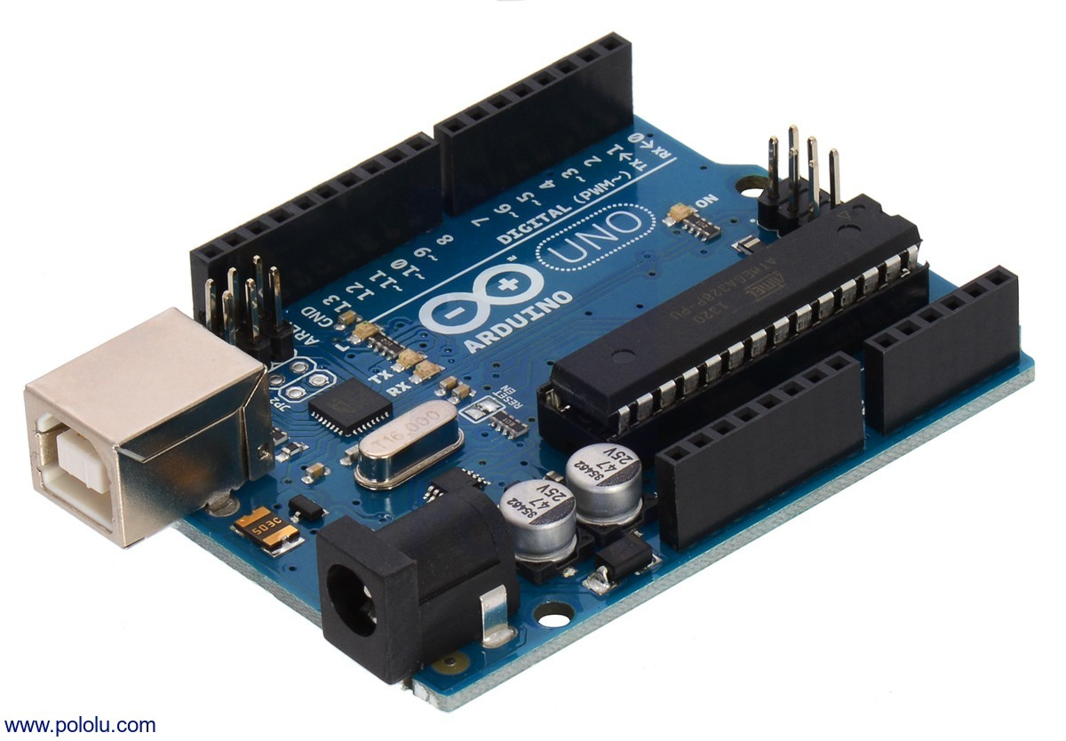

can be established by connecting Arduino to personal computer with a USB cable, power with AC to DC adapter can be provided or battery to get started. Arduino is a firm which design hardware, μC based kits for building digital devices and interactive objects that can percept and control physical devices. It establish a serial communication interface for loading programs from PC through USB.

* ***HC-05***

A HC-05 module is an easy to use Bluetooth SPP (Serial Port Protocol) module, designed for transparent wireless serial connection setup. Serial port Bluetooth module is fully qualified Bluetooth V2.0+EDR (Enhanced Data Rate) 3Mbps Modulation with complete 2.4GHz radio transceiver and baseband. It uses CSR Blue core 04-External single chip Bluetooth system with CMOS technology and with AFH (Adaptive Frequency Hopping Feature). It has the footprint as small as 12.7mmx27mm. Hope it will simplify your overall design/development cycle. to use Bluetooth SPP (special pot protocol) module. It setup a transparent wireless serial connection. HC-05 is a fully qualified Bluetooth supporting V2.0+EDR(enhanced data rate), 3Mbps modulation, 2.4 GHz baseband and use CSR Bluecore 04- External single chip Bluetooth system. Its footprint is very small limiting up to 12.7 mm X 27 mm, its default baud rate is 38400. It underpin master and slave concept, and if the master and slave are paired then red and blue LEDs on the module blinks at 1 time per 2 seconds in interval and if disconnected blue LED blinks for 2 times per second. Its auto pairing pin code is “0000” as default and it automatically reconnect in 30 min when disconnected because of exciding the range of connection.

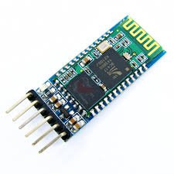

* ***Android Phone and platform:***

In this project we will control the robot using Android Phone by using an application which we will get from Android Play store. By installing the application we can move the robot in four direction i.e., is front, reverse, left and right directions [7]. Android is a mobile operating system developed by Google based on Linus Kernel and is mostly wield with touch screen smart phones .Android platform is reliable for building an android application, android is a common choice of people while they buy any cell phone. Android provides easy accessibility and understandability of different aspects for daily use. They are widely known as mobile computers and are expanding the sale of smartphones worldwide. They are widely accepted as they provide open architecture, platform independent and enormous capabilities. It is built from JAVA programming language and as android uses JAVA, android API provide easy access for hardware components. Android may use USB, Wi-Fi and Bluetooth for connecting with the robot.



* **Android Studio:** For building an android app android studio is looked for, android studio is an Integrated Development Environment (IDE) for android app development. The first stable build was released in December 2014, starting from version 1.0, based on JetBrains IntelliJ IDEA software, Android Studio is designed specifically for Android app development. It can be downloaded at Windows, Mac and Linux smoothly, and replaced Eclipse Android Development Tools (ADT) which is Google's primary IDE for indigene application development. It has Gradle based build support, Lint tools to catch performance and version compatibility. Android studio is a well-to-do layout editor which allows users to drag-and-drop UI components, and even provide user with option to preview layouts on multiple screens.
* ***Bluetooth Receiver:***

Bluetooth Receiver consists of Bluetooth serial interface module and Bluetooth adapter. Bluetooth serial module is used for converting serial port to Bluetooth. This module has two modes: master and slaver device. The device named after even number is defined to be master or slaver when out of factory and can’t change to the other mode. But for the device named after odd number, users can set the work mode (master or slaver) of the device by AT commands [8][9].

* ***L298:***

The L298 is an integrated monolithic circuit in a 15lead Multiwatt and PowerSO20 packages. It is a high voltage, high current dual full-bridge driver designed to accept standard TTL logic levels and drive inductive loads such as relays, solenoids, DC and stepping motors. Two enable inputs are provided to enable or disable the device independently of the input signals. The emitters of the lower transistors of each bridge are connected together and the corresponding external terminal can be 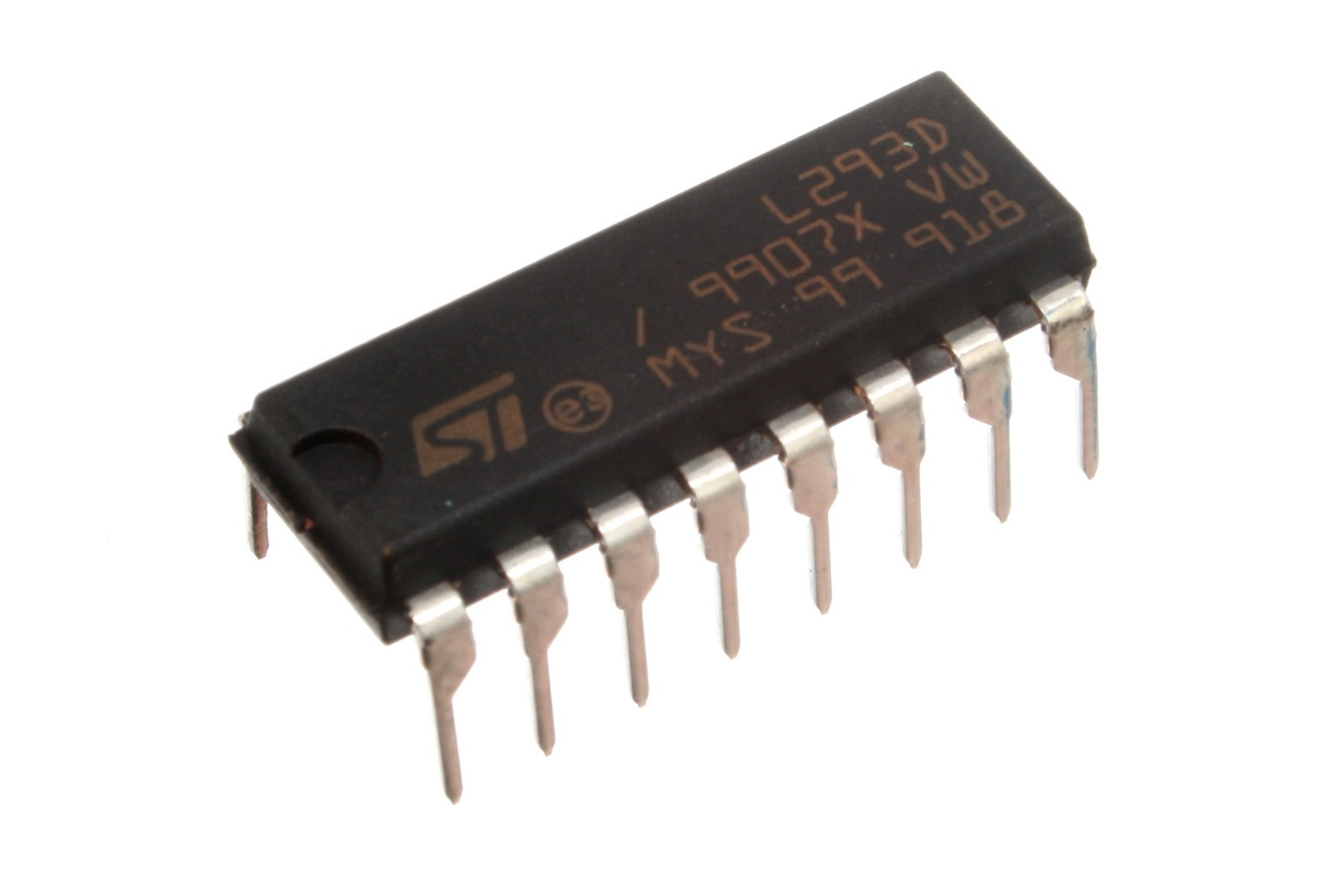

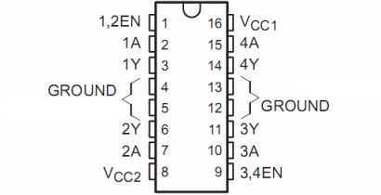

used for the connection of an external sensing resistor. An additional supply input is provided so that the logic works at a lower voltage.

L293D is a motor driver IC which allows the motor driver to move in any direction. With the help of motor driver, two DC motor can be attached on a single IC and both of them can be moved in either directions. L293D is a 16 pin IC which can control a set of direct current motors, Dual H-bridge Motor Driver integrated circuit(IC).This driver drives small as well as quite big motors, and it works on the concept of H-bridge circuit which allows the voltage to be flown in any direction. H-bridge is ideal for driving a DC motor as the voltage needs to change the direction of the motor to make it move it in either clockwise or anti-clockwise direction. L293D pin diagram consist 4 input pins, 2, 7 are the left pins and 15, 10 are the right pins these pins regulate the rotation of the motor in either left side or right side. Inputs are given as Logic 0 (low) and Logic 1 (high), for rotating the motor the low and high signals are provided. It has Vcc pin where voltage required for internal operation is specified maximum of 5V supply can be provided. Vss or ground pin is there where we can apply voltage for driving the motor, maximum of 36 V supply can be applied. Maximum of 600mA current per channel can flow in the circuit.

* ***DC Motor:***

Almost every mechanical movement that we see around us is accomplished by an electric motor. Electric machines are means of converting energy. Motors take electrical energy and produce mechanical energy. Electric motor is used to power hundreds of devices we use in everyday life. An example of small motor applications includes motors used in automobiles, robot, hand power tools and food blenders. Micro-machines are electric machines with parts the size of red

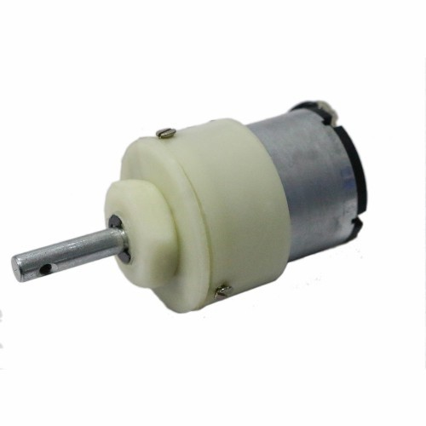

blood cells and find many applications in medicine. Direct current motor is an electric motor which is capable of handling mechanical movements by converting conventional energy. DC motor takes electrical energy and produces mechanical energy. Dc motors are usually referred to as power devices, which are specifically used in auto mobiles, food blenders and so in robots. It is an electrical machine convertor which converts DC electric power to mechanical power and basically rely on the forces composed by magnetic field. It have either electro mechanical or electronics as internal mechanism to periodically change the direction of the current flow, mostly produces rotatory motion while some produce force directly and motion in the straight line.

* ***SOFTWARE DESCRIPTION:***

The smart microcontroller unit named as Arduino Uno can be programmed with the Arduino software there in no any requirement for installing other software rather than Arduino. Firstly, Select "Arduino Uno from the Tools , Board menu (according to the microcontroller on your board).The IC used named as ATmega328 on the Arduino Uno comes pre burned with a boot loader that allows you to upload new code to it without the use of an external hardware programmer. Communication is using the original STK500 protocol (reference, C header files).We can also bypass the boot loader and programs the microcontroller through the ICSP (In Circuit Serial Programming) header. The ATmega16U2 (or 8U2 in the rev1 and rev2 boards) firmware source code is available. The ATmega16U2/8U2 is loaded with a DFU boot loader, which can be activated by: On Rev1 boards: connecting the solder jumper on the back of the board (near the map of Italy) and then resetting the 8U2. On Rev2 or later boards: there is a resistor that pulling the 8U2/16U2 HWB line to ground, making it easier to put into DFU mode.

The Arduino Uno is one of the latest smart microcontroller unit and has a number of facilities for communicating with a computer, another Arduino, or other microcontrollers. The ATmega328 provides UART TTL at (5V) with serial communication, which is available on digital pins 0 - -(RX) for receive the data and pin no.1 (TX) for transmit the data. An ATmega16U2 on the board channels this serial communication over USB and appears as a virtual com port to software on the computer. The '16U2 firmware uses the standard USB COM drivers, and no external driver is needed. However, on Windows, an .inf file is required. The Arduino software includes a serial monitor which allows simple textual data to be sent to and from the Arduino board. The RX and TX LEDs on the board will flash when data is being transmitted via the USB-to-serial chip and USB connection to the computer (but not for serial communication on pins 0 and 1). A Software Serial library allows for serial communication on any of the Uno's digital pins. The ATmega328 also supports I2C (TWI) and SPI communication. The Arduino software includes a Wire library to simplify use of the I2C bus. Arduino programs are written in C or C++ and the program code written for Arduino is called sketch. The Arduino IDE uses the GNU tool chain and AVR Libc to compile programs, and for uploading the programs it uses avrdude. As the Arduino platform uses Atmel microcontrollers, Atmel's development environment, AVR Studio or the newer Atmel Studio, may also be used to develop software for the Arduino.

IDE is an integrated development environment based on programming language named as Processing, it also support C and C++. It basically is a cross-platform application written in JAVA. IDE is basically for software programming of any hardware board or IC. This code editor have following features: Syntax highlighting, brace matching, automatic indentation, one-click mechanism for loading and compiling of the programs on the Arduino board. In IDE program written is known as Sketch. C/C++ sketch consist of two functions which are compiled and amalgamate with a program stubmain().

• setup(): this function runs at the beginning or start of the program and even initialize the settings.

• Loop(): this function is called repeatedly until the board power is cut-off.

* **BLOCK DIAGRAM**



* **DESIGN AND IMPLEMENTATION**

The robot is made up of an Arduino board, motor driver, 2 DC motors, Bluetooth module HC-05. Firstly the data from the android app is sent as an input to the Bluetooth module which further gives it to the Arduino Uno, Uno is a controller which controls the signals and performs the assigned functions it understands which signals have to be forwarded to the motor driver so that it moves in particular order. Like in if the user have tapped the left button on the app the Arduino will send the signal to the motor driver to activate the left pins and accordingly move the motors so that the wheels can follow the direction.

As shown in the block diagram, User give directions through the app to the microcontroller with the help of Bluetooth module, then Arduino handles the motor driver which further supports the dc motors and enable the high signal at 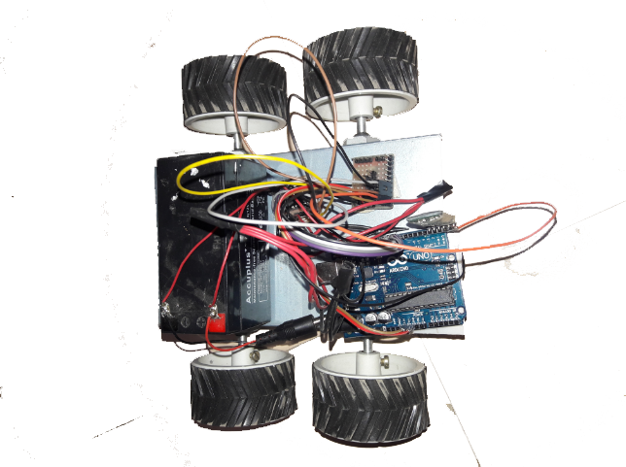

specific motor pins. The motor driver has several pins and those pins are for power supply, ground, and each dc motor have its own respective pins which when gets a high signal activates the dc motor, like pins 5,6 for the left motor and 9,10 for the right motor. Now the distance of the obstacle from the robot is calculated by the ultrasonic sensor which in turn gives a serial output on the app screen showing the distance.

* **Code:**

char data = "0";

void setup() {

// put your setup code here, to run once:

pinMode(8,OUTPUT);

pinMode(9,OUTPUT);

pinMode(10,OUTPUT);

pinMode(11,OUTPUT);

Serial.begin(9600);

}

void loop() {

// put your main code here, to run repeatedly:

if(Serial.available() > 0) // Send data only when you receive data:

{Serial.setTimeout(1);

String a= Serial.readString();

//Read the incoming data & store into data

Serial.print(a); //Print Value inside data in Serial monitor

Serial.print("\n");

if(a.equals( "1")) // Checks whether value of data is equal to 1

{forward();

}else if(a.equals( "2")) // Checks whether value of data is equal to 1

{back();

}else if(a.equals( "3")) // Checks whether value of data is equal to 1

{left();

}else if(a.equals( "4")) // Checks whether value of data is equal to 1

{right();//If value is 1 then LED turns ON

} else stopp(); }

}

void right(){

digitalWrite(8,HIGH);

digitalWrite(10,LOW);

digitalWrite(9,LOW);

digitalWrite(11,HIGH);

}

void left(){

digitalWrite(8,LOW);

digitalWrite(10,HIGH);

digitalWrite(9,HIGH);

digitalWrite(11,LOW);

}

void forward(){

digitalWrite(8,HIGH);

digitalWrite(10,HIGH);

digitalWrite(9,LOW);

digitalWrite(11,LOW);

} void back(){

digitalWrite(8,LOW);

digitalWrite(10,LOW);

digitalWrite(9,HIGH);

digitalWrite(11,HIGH);

}

void stopp(){

digitalWrite(8,LOW);

digitalWrite(10,LOW);

digitalWrite(9,LOW);

digitalWrite(11,LOW);

}

* **CONCLUSION**

The purpose of project is to introduce a hardware system which can transfer small requirements from a room to another by just tapping on one’s mobile screen. The hardware here introduced is a compound robot which is handled by an android application, the connectivity between the robot and the app is done by HC-05 Bluetooth module, which provides 5 meters range from its current position. Completion of this project will bring a new product to the world to increase speed and efficiency. Thus it is concluded as by introduction of any such robot will enhance smart work and one can control their task remotely and wirelessly.